EXERCISE 4
- List the first and last names of all employees who draw less than or equal to $90000 and are not Programmes, Senior programmer or Multimedia programmers.
select f_name, l_name FROM employee_data WHERE salary <= 90000 AND title NOT IN ('Programmer', 'Senior Programmer', 'Multimedia Programmer');
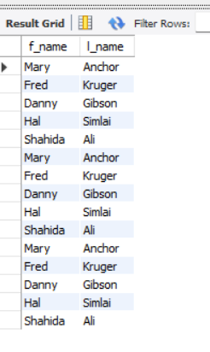
- What is displayed by the following statement?
SELECT l_name, f_name from employee_data where title NOT LIKE ‘%marketing%’ AND age < 30;
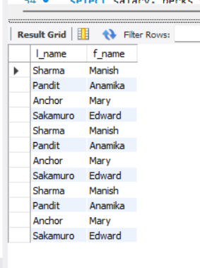
- List all ids and names of all employees between 32 and 40 years of age.
select ids, f_name, l_name FROM employee_data WHERE age BETWEEN 32 AND 40;

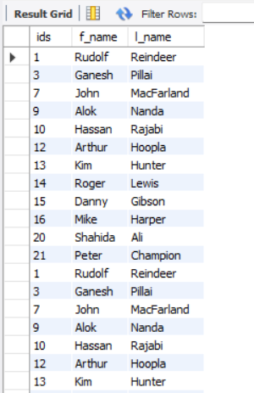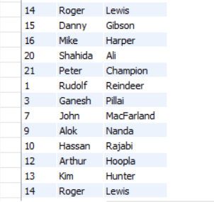
- Select names of all employees who are 32 years of age and are not programmers.
select f_name, l_name FROM employee_data WHERE age = 32 AND title != 'Programmer';
